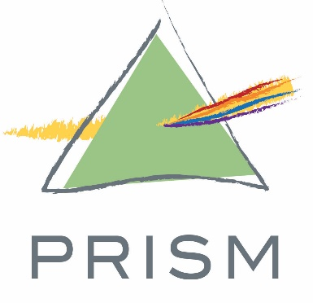

PRISM Board Member Posting:

PRISM is a nonprofit community-supported social service organization. Our mission is to provide social services and connections that empower people in our community to build healthy, stable lives. Located in Golden Valley, we help over 700 families a month access food, clothing, and housing in times of financial hardship.
PRISM is seeking talented individuals to join its Board of Directors.
As a board member you are responsible for strategic, financial and organizational planning, oversight, and resource development. We have an engaged board of professionals with an array of professional and personal experiences. To complement our existing board, we are particularly interested in candidates with expertise in law, accounting, marketing, nonprofit management, or finance.

Job Description: Board Member
PRISM is seeking new members to join its Board of Directors. Ideal candidates for the open Board roles will have diverse experiences and backgrounds. Although not required, previous experience in nonprofit leadership and/or governance is helpful. This is a volunteer position, with a three-year term. PRISM carries Directors and Officers Insurance for all board members.
PRISM is a 501(c) (3) nonprofit community-supported social service organization, located in Golden Valley, that helps people access food, clothing, and housing in times of financial hardship. Additionally, PRISM provides education and assistance to utilize community services for specific needs such as domestic violence, employment, subsidized housing, senior service, health/medical/dental needs, mental health, substance abuse, and more. Key programs include:
- PRISM Marketplace Food Shelf is a choice-model (grocery store style) food shelf that allows families to choose their own 5-7 day supply of food.

- Financial Assistance/Homelessness Prevention provides assistance for families, paid directly to landlords to ensure stable housing during times of financial crisis.

- Shop for Change thrift shop offers clothing and small household items for program participants as well as the general community. Individuals and families in need receive gift certificates to ensure access to needed items.

- School Supplies are distributed to over 600 children each fall. Community groups hold school supply drives each July and August to gather needed materials for students returning to school.

- Holidays & Birthdays are recognized by providing parents with birthday gifts, party supplies, cakes, holiday gifts and more so kids can enjoy family celebrations without causing a financial hardship to the family.
Responsibilities of the Board:
- Determining the mission and purposes of PRISM
- Selecting and evaluating the performance of the Executive Director
- Strategic and organizational planning
- Ensuring strong fiduciary oversight and financial management
  - PRISM’s current annual budget: $2.7 Million
- Fundraising, friend-raising, networking and overall resource development
- Approving and monitoring PRISM’s programs and services
- Enhancing PRISM’s public image
- Assessing its own performance as the governing body of PRISM

Responsibilities of Position:
- Attend monthly board meetings in person or vis conference call; 9-12 meetings held per year
- Actively serve on at least one committee; attending a monthly or bi-monthly committee meeting; special assignments/ad hoc projects
- Review agenda, emails and supporting documents prior to meetings
- Make an annual contribution to PRISM commensurate with ability
- Participate in & share information about PRISM’s fundraising activities & special events
- Demonstrate strong leadership and ethical decision making skills
- Understand and promote PRISM’s mission, vision and values
- Be familiar with PRISM’s programs, policies, and operations
- Keep current on hunger, housing and related program-specific issues
- Strictly adhere to conflict of interest policies and confidentiality policies
- Follow PRISM’s bylaws, policies, and board resolutions

Mission Vision Values:
Mission: PRISM’s mission is to provide social services and connections that empower people in our community to build healthy, stable lives.
Vision: PRISM’s vision is to lead in providing innovative and dignified services that foster resilient individuals and a healthier, more sustainable community.
Values:
- Dignity: PRISM’s interactions with participants, staff, volunteers, and partners come from a place of respect and mutuality.
- Accountability: PRISM is transparent and adept with its resources and person-centered with its services.
- Collaboration: PRISM is committed to working in synergy with participants, volunteers, and partners to best respond to the needs of our community.
- Innovation: PRISM is flexible and forward-thinking as it continuously seeks to improve work and outcomes.
Contact Michelle Ness to learn more: mness@prismmpls.org, 763.432.4201

More information about the roles and responsibilities of non-profit boards can be found at http://www.minnesotanonprofits.org/nonprofit-resources/leadership-governance/board-basics/roles-and-responsibilities-of-the-nonprofit-board

Interested candidates are encouraged to attend a governance training session offered through Propel and MCN.
http://www.minnesotanonprofits.org/events-training/training-calendar
https://www.propelnonprofits.org/upcoming-trainings/

